# Steps to create and assign a custom policy definition to a particular scope:

1. **Sign in to the Azure portal:** Go to the Azure portal and sign in with your account.
2. **Create a custom policy definition:** In the left navigation pane, select **Policy**. In the **Policy** pane, select **Definitions**. Select **+ Policy definition**. Fill in the required information 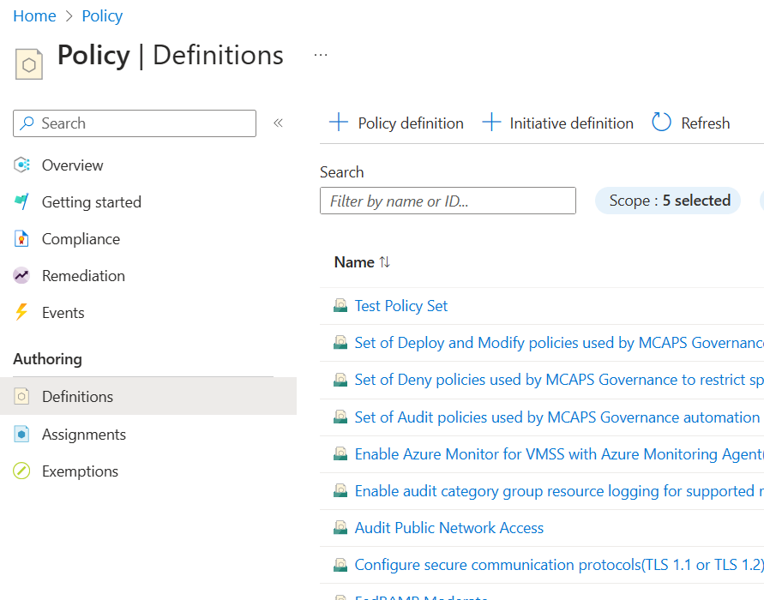
3. Choose the scope of the location, name, description and policy definition in json format and select **Save**.

1. **Assign the policy definition:** In the **Policy** pane, select **Assignments**. Select **+ Policy assignment**. Fill in the required information like scope of the Policy, choose policy definitions, Assignment Name, parameters.

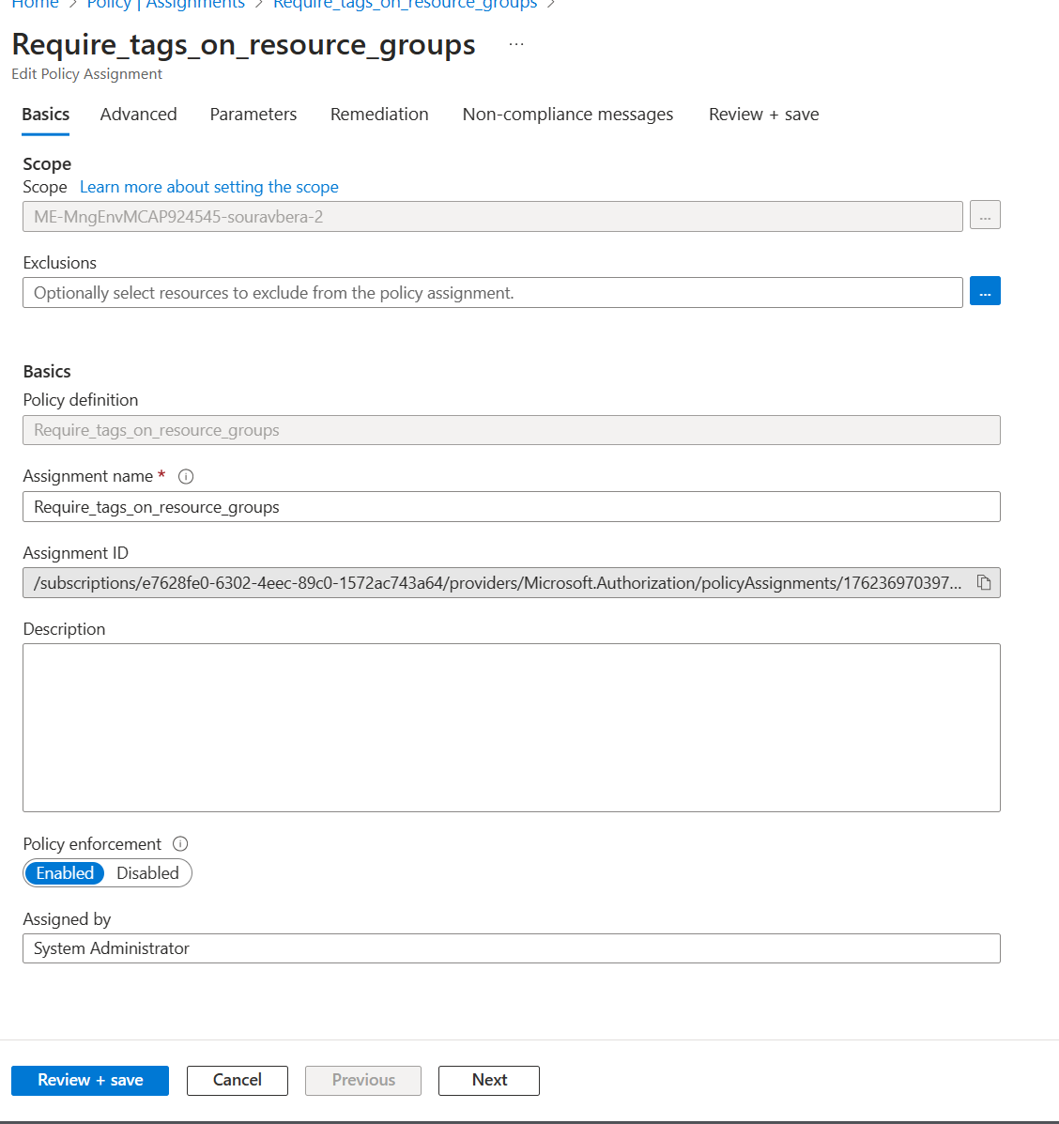

1. Setup remediation (if the policy is set to modify), etc. select a managed Identity to perform the remediation and select **Review + create**. Review the information and select **Create**.